

Design Thinking Project:
Future Digital Campus

SECP1513: Technology and Information System
(Section 4 Group 7)

Lecturer: Dr. Shafaatunnur Binti Hasan

Member Details:
- Wong Jian Fu (A25CS0158)
- Raestra Palevie Hamid (A25CS0384)
- Rhiddhi Subha Siddique (A24CS4090)
- Ariff Naim bin Zamzan (A25CS0195)

Table of Contents
Introduction 3
Design Thinking Process 3
Empathy Phase 3
Define Phase 4
Ideate Phase 4
Prototyping Phase 5
Testing Phase 6
Project Description 6
Problem Statement 6
Problem Solution 6
Team Working 7
Assessment Point 7
End of Project Demonstration 8
Transition Between Design Thinking Phases 9
Design Thinking Evidence 10
Empathy Phase 10
Ideate Phase 14
Prototyping Phase 14
Testing Phase 15
Reflection 16
Task Assignment 18

Introduction
Nowadays, AI assistants are widely used as tools among students. It helps them by making the information searching process much easier, allowing them to study more efficiently. Most of the AI assistants used by students are AI chatbots, for example, ChatGPT, Gemini, and DeepSeek. Although these chatbots can answer most of the academic questions, they still lack the ability to answer specific questions about campus that are not general. Students often find it hard to search for information such as transportation time, exam information, classroom location, etc. This project aims to build an AI assistant that is trained specifically to answer any campus-related questions and also plan their schedule based on their classes.

Design Thinking Process
In December 2025, we as a team have come up with a prototype called UTM AI Campus Life Assistant based on the theme “Future Digital” with the primary purpose being providing students and staff alike an easy way to gain information involving UTM such as campus map and navigation, timetable, transportation and so on. Its goal is to make the user campus life experience less stressful and easier.

Empathy Phase
First, we identified the target users who are university students. Next, we observed the struggle of students, especially freshmen navigating around the campus. We have also reviewed common complaints amongst students related to information access and scheduling. These issues show the struggles students have navigating large and complex campus environments. The importance of class schedules reminders, a convenient way to access campus-related information such as the bus schedules and routes, events information and so on should be highlighted.

Define Phase
Based on the information gathered during the empathy phase, several key problems were identified. Students face a problem managing their campus activities due to lack of information and inadequate support. Three main problems were noted during our research which are difficulty navigating around campus buildings and facilities, poor time management caused by forgetting class schedules and the lack of personalized assistance in the existing methods. These issues show the main focus of solutions to simplify campus navigation, help students manage their class schedules reminders and provide an intelligent and user-friendly campus assistant.

Ideate Phase
In this phase, the team brainstormed multiple ideas that could help to tackle the identified problems. Various digital solutions were discussed as a way to improve student convenience and campus life experience. Mobile campus navigation application, AI chatbot for campus related questions, timetable reminder system, Campus Information Hub are amongst the various solutions we came up with. We came up with the idea of an AI powered campus life assistant that combines navigation, timetable reminders and easy access to campus information. We have also refined it with the AI assistant capability to answer campus related questions, providing an interactive campus map with indoor and outdoor navigation, personalized class timetable reminders with notifications and an information hub which includes general information and latest ones such as events and announcements.

Prototyping Phase
Based on the refined ideas, the team managed to turn the ideas into a prototype. The prototype was designed to help students visualize the interaction with the AI campus assistant and how all previously discussed features would function together.
Step 1: Student features
- Student account login
- AI chat assistant interface
- Campus map and navigation feature
- Class timetable and reminder system

Step 2: User flow
- Students log in to the AI campus assistant platform
- Students ask questions or request navigation through the AI assistant
- Students view campus maps and receive navigation guidance
- Students receive notification reminders for classes and important activities

Step 3: Create prototype
- AI chat interface
- Campus navigation page
- Timetable and reminder dashboard
- Notification system

Testing Phase
At this point, testing was conducted to evaluate the features mentioned and their functionality. Feedback was collected to understand student challenges and what feature they would like to be introduced within the AI assistant. The majority of the respondents noted that they are willing to use the AI Campus Life Assistant and are confident that it would improve the quality of student life.

Project Description

Problem Statement
UTM students often face problems with transportation. The bus travel time is not straightforward, and in order to reach some place in UTM, students need to change buses to get there. The schedule given by UTM Fleet is hard for students to plan their trip if they need to change buses. Besides that, students also have problems finding information about campus. Although most of the information can be found on the UTM official website, most of it is hard to find.

Problem Solution
The UTM AI Campus Life Assistant is suggested as an integrated, AI-powered solution to deal with typical issues that staff and students have when managing campus life, based on the produced prototype. The system includes an interactive campus map that facilitates building and facility navigation, as well as an AI chat assistant that allows users to ask inquiries about the campus and obtain accurate data fast. Additionally, users can better organize their class schedules and key activities with the use of a customized timetable and reminder system. The suggested solution is to decrease confusion, enhance time management, and provide a more comfortable and stress-free campus experience at UTM by combining campus information, including academic calendars, locations, announcements, and services, into a single platform.

Team Working
Throughout the design thinking process, effective teamwork was important to the project's progress. Team members worked closely together throughout each process, including empathy, define, ideate, prototype, and testing, by sharing ideas, conducting discussions, and providing constructive feedback. Brainstorming meetings were organized to explore different points of view and refine concepts based on user demands, and assignments were distributed based on individual strengths to ensure efficiency and balanced contribution. Regular communication and cooperation enabled the team to overcome problems, make informed design decisions, and match the prototype with the project's goals. This collaborative approach contributed to a complete and user-centered design.

Assessment Point
Our journey through this Design Thinking project was not only about following steps, but also it was about learning to see the campus through the eyes of our fellow students. Our work was continually assessed not by a rigid checklist, but by our ability to genuinely connect with user needs and translate them into a tangible, helpful solution. We held ourselves accountable at each stage by asking key questions:

- Empathy Phase: Did we truly listen and understand the daily frustrations of navigating UTM life, or were we just making assumptions? Our survey was our first real checkpoint, forcing us to confront the actual struggles with bus schedules and hidden information.
- Define Phase: Could we clearly and compassionately articulate the core problems? Moving from a list of complaints to a focused problem statement was a crucial test of our analytical skills, ensuring we were solving the right issues.
- Ideate Phase: Did we think boldly and creatively, or did we settle for the obvious? Our brainstorming sessions were assessed on their energy and diversity of ideas, pushing us to combine features like navigation and AI chat into a single, powerful assistant.
- Prototype Phase: Did our idea take a shape that users could see, feel, and react to? Building the prototype was our test of practicality. Could we visually communicate our vision for a seamless digital helper?
- Test Phase: Did we have the humility to learn from feedback? Presenting our prototype to peers was the ultimate assessment, telling us if we had succeeded in making something they would actually trust and use daily.

This ongoing self-assessment ensured our project remained a human-centered mission, not just a technical exercise.

End of Project Demonstration
The final demonstration was where our months of research, brainstorming, and design finally came to life. We presented the UTM AI Campus Life Assistant not as a collection of features, but as a unified companion for campus life. We walked our audience through a typical student’s day:

- Starting the Day: We showed how the assistant provides gentle, proactive reminders for a student’s first class, not just as a calendar alert, but with a helpful note like, “Your CSC101 lecture starts in 45 minutes. The K10 bus to FSKSM arrives at your stop in 10 minutes.”
- Navigating a New Challenge: We demonstrated a student feeling lost, asking the AI chat, “Where is the Dean’s Office at FABU?” The assistant instantly provided clear instructions and opened the interactive map with a guided path, turning anxiety into confidence.
- Accessing Vital Information: We simulated the scramble for last-minute information, showing how a user could ask, “When is the last bus from KL to UTM tonight?” and receive an accurate, real-time answer pulled from integrated campus databases, eliminating endless website searches.
- The Unified Hub: We emphasized how all these functions, such as schedule, map, chat, and announcements, live in one friendly, familiar app. The demonstration concluded by highlighting how this integration actively reduces mental load, helping students focus on learning and connecting, rather than on logistics and frustration.

The positive reaction and willingness to use the assistant confirmed that we had successfully translated student pain points into a digital solution that felt intuitive, supportive, and genuinely useful.

Transition Between Design Thinking Phases
The progression through the design thinking framework was not merely a linear sequence of tasks, but rather an evolving dialogue with the problem space. Each transition represented a critical moment of synthesis, where insights from one phase were distilled into actionable direction for the next, ensuring the project remained both impactful and empathetically grounded.
- From Empathy to Define:
This transition marked a shift from immersion to interpretation. Confronted with qualitative data from surveys, the lived frustrations of navigating bus schedules and locating information, we moved beyond individual evidence to identify systemic patterns. Through collaborative discussion, we reframed complaints into the core challenges of information fragmentation and a lack of integrated guidance. This act of synthesis was essential to ensure our subsequent efforts targeted underlying causes, not just symptomatic inconveniences.
- From Define to Ideate:
With clearly articulated problem statements as our guiding criteria, our ideation sessions became exercises in focused creativity. Brainstorming was no longer a free-form exercise; each proposed concept was evaluated against its potential to directly resolve the defined issues of navigation, time management, or information access. This constraint fostered innovative yet practical solutions, such as integrating an AI conversational interface with real-time mapping, ensuring our creativity was purposefully channeled.
- From Ideate to Prototype:
This phase transitioned our work from the conceptual to the concrete. Selecting the integrated AI assistant concept required us to answer a new set of questions regarding form and interaction. We moved from discussing abstract features to specifying tangible user flows: How would a reminder be triggered? What specific data would a navigation prompt include? Developing the Figma prototype necessitated making definitive decisions, translating our favored ideas into a visual and interactive artifact that could be experienced and evaluated.
- From Prototype to Test:
The final transition represented a commitment to external validation and intellectual humility. Sharing our prototype shifted the project's locus from our internal assumptions to the users lived experience. Observing real interactions and soliciting candid feedback, such as the preference for simpler conversational language, provided an indispensable layer of refinement. This step ensured the solution evolved from a team's "final" prototype into a genuinely user-validated tool.

Design Thinking Evidence

Empathy Phase
To learn more about the difficulties students face, our team published a survey via Google Forms. This survey will help us understand what features should be included in our AI assistant to help students with their challenges.

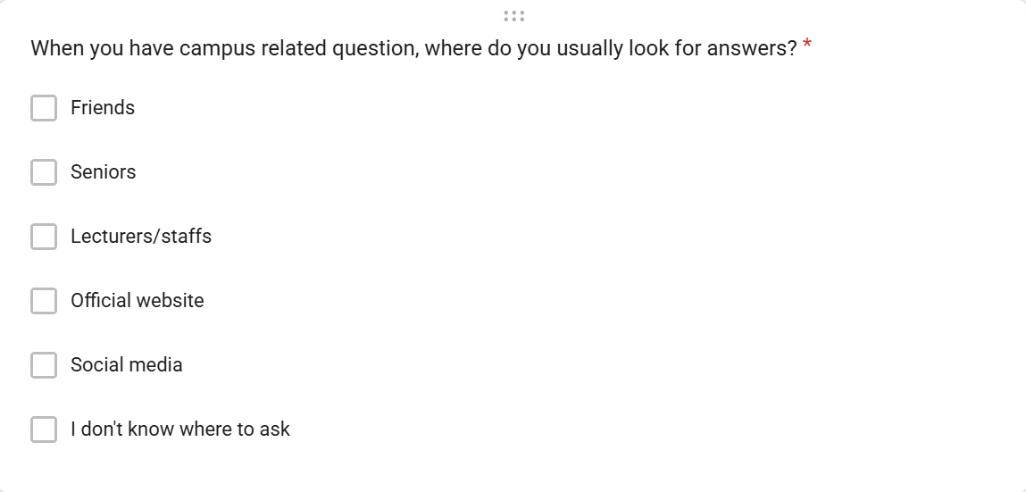
Figure 1.0 Google Forms

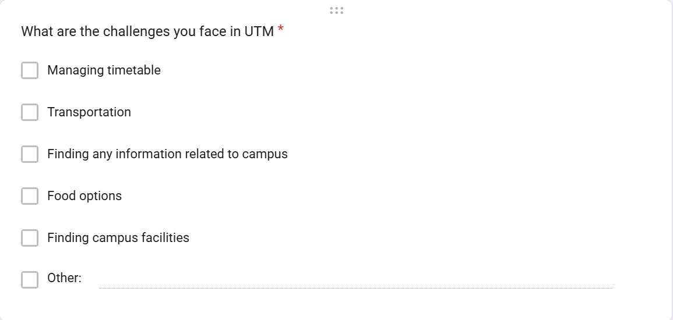
Figure 1.1 Google Forms

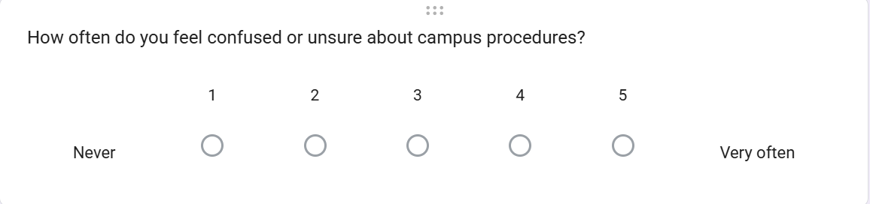
Figure 1.2 Google Forms

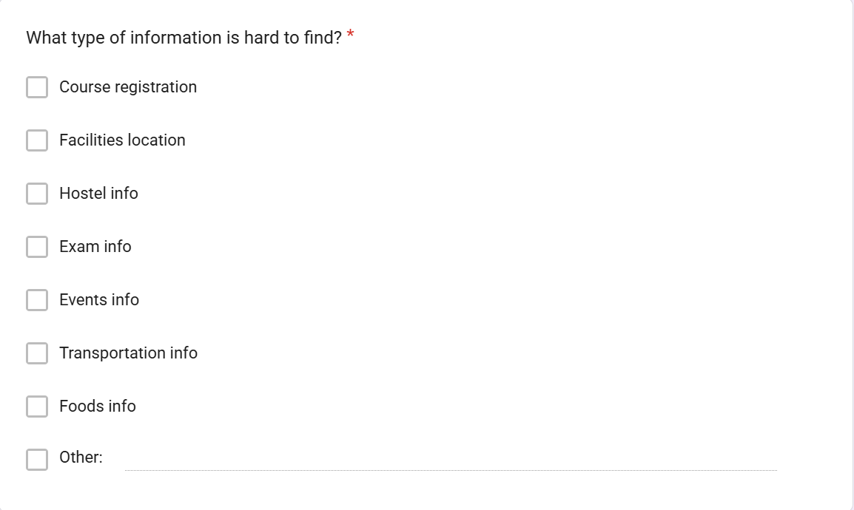
Figure 1.3 Google Forms

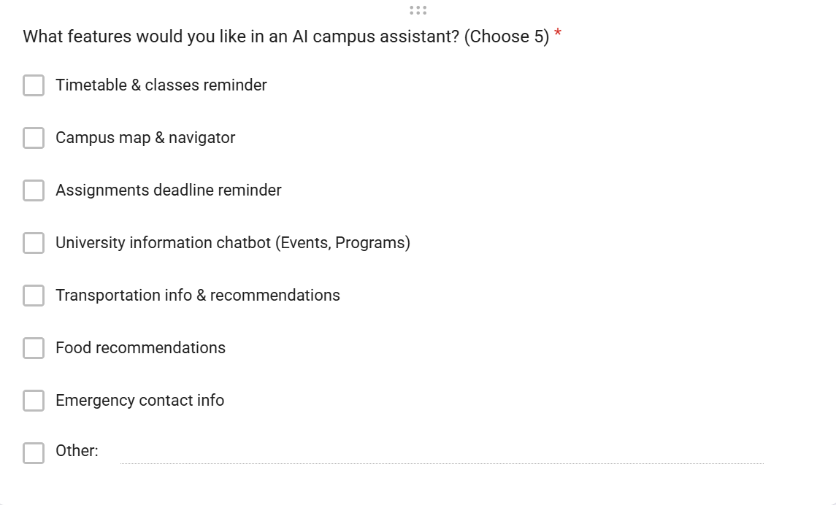
Figure 1.4 Google Forms

Define Phase
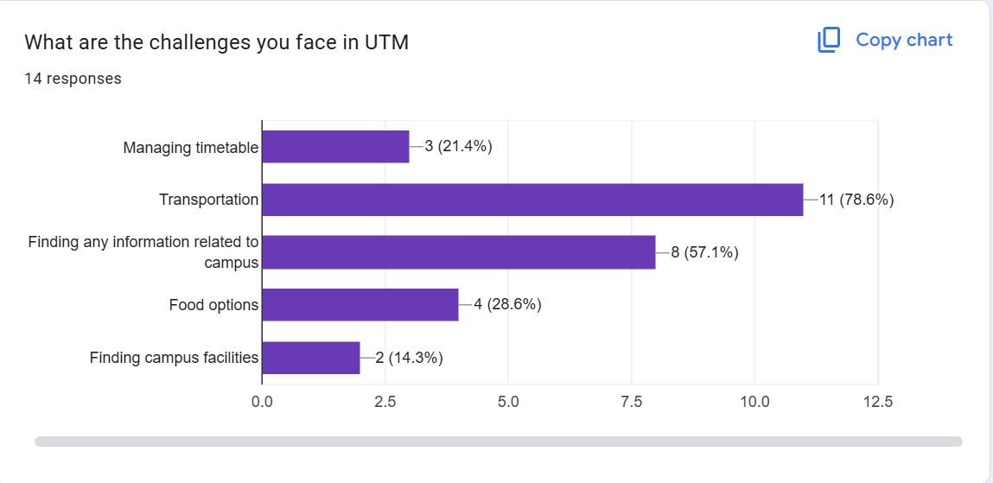
Figure 2.0

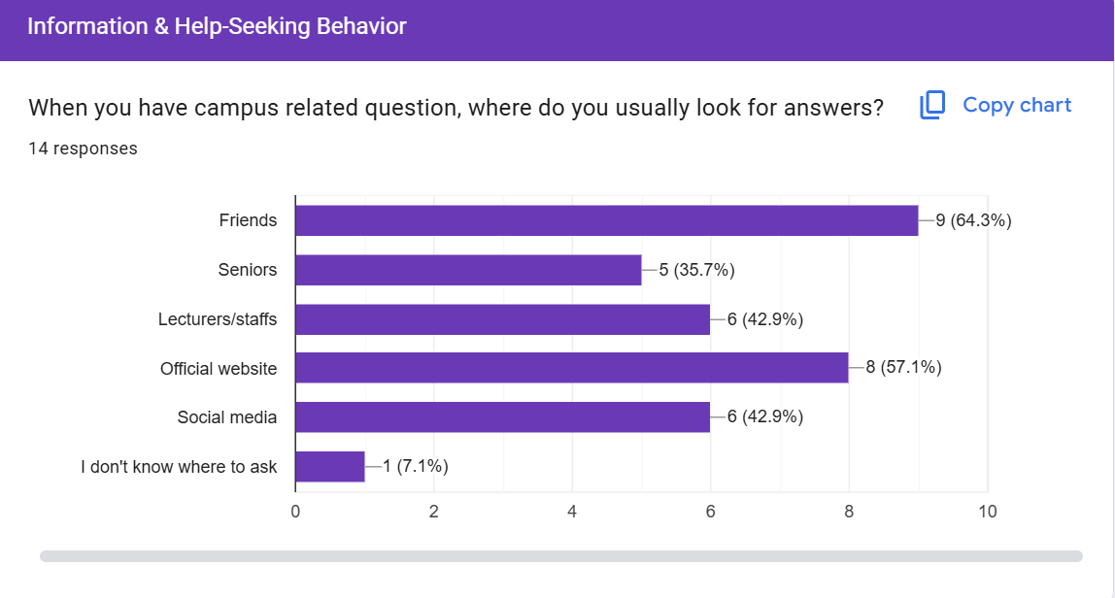
Figure 2.1
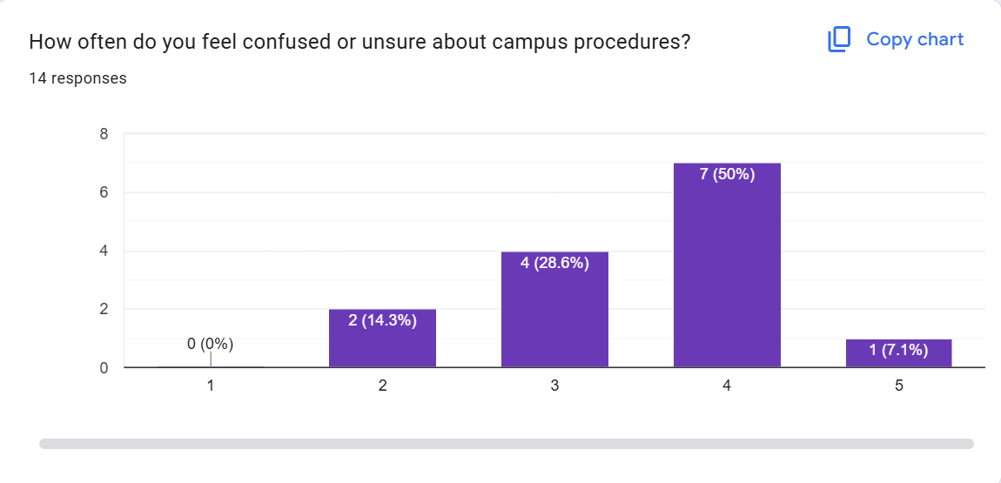
Figure 2.2
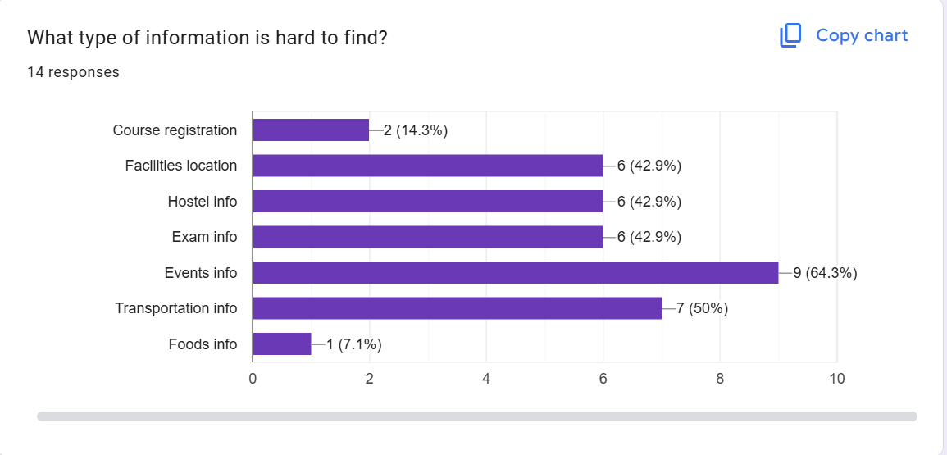
Figure 2.3

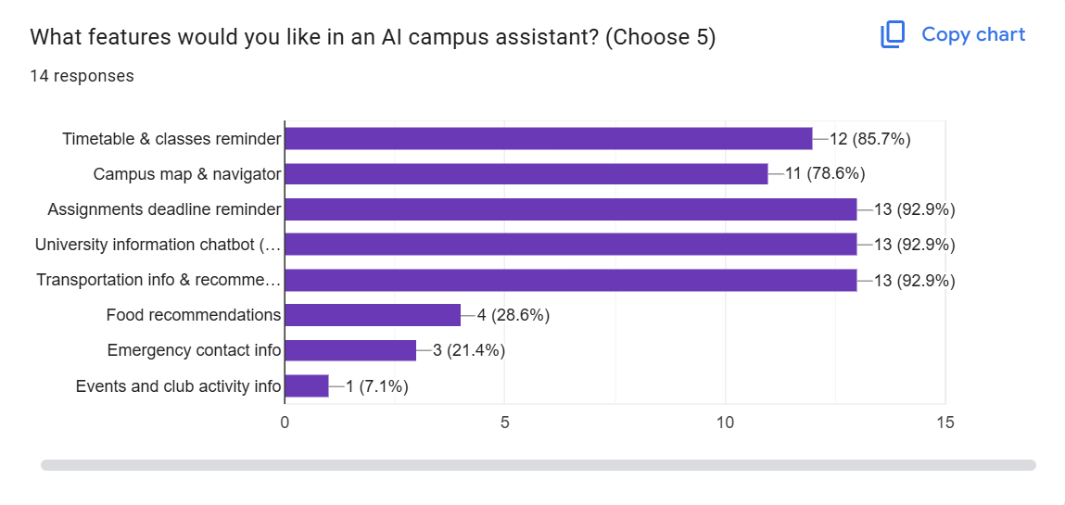
Figure 2.4

Ideate Phase
We held a meeting to discuss various solutions to satisfy user needs using the data we had gathered in previous stages in this phase.
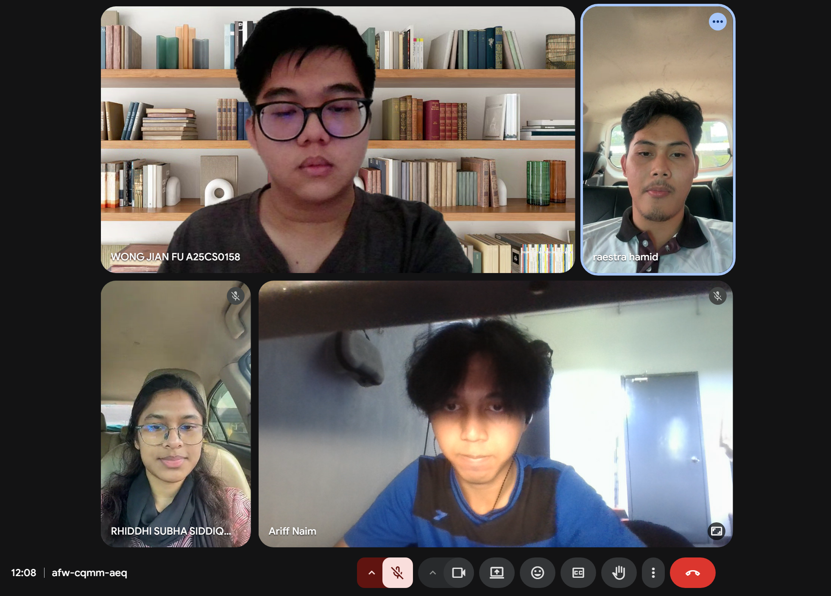
Figure 3.0

Prototyping Phase
We created the prototype in this phase based on the knowledge, concepts and data we had collected in previous stages.
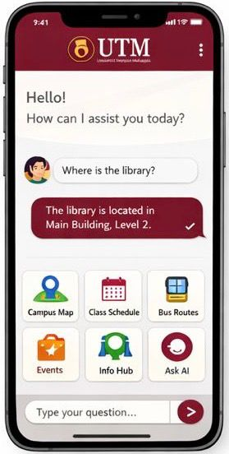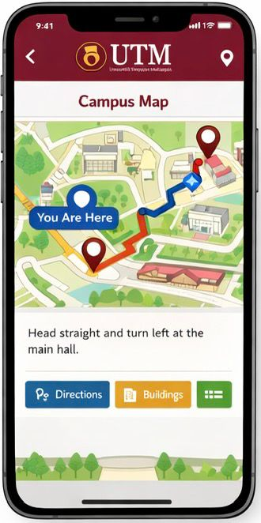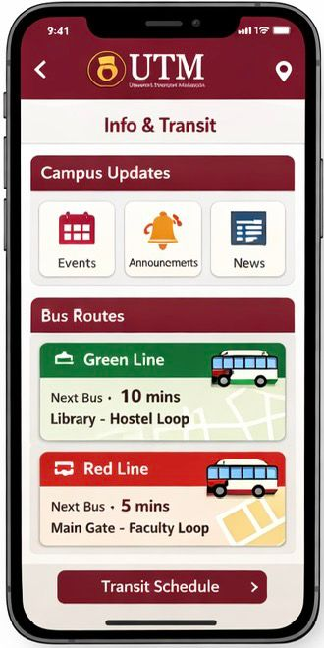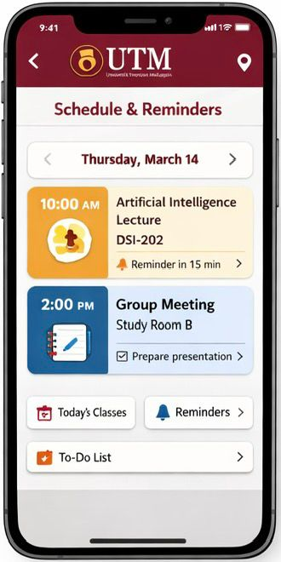
Figure 4.0 Figure 4.1 Figure 4.2 Figure 4.3

Testing Phase
We asked a few users to give their feedback on our prototype during the testing phase. Most people are willing to use our UTM AI Campus Life Assistant and liked the concept of it.

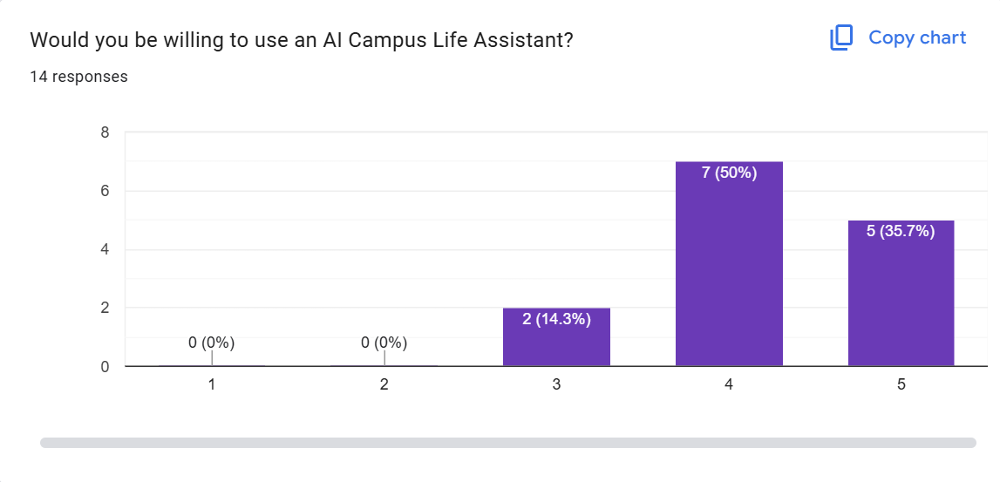
Figure 5.0

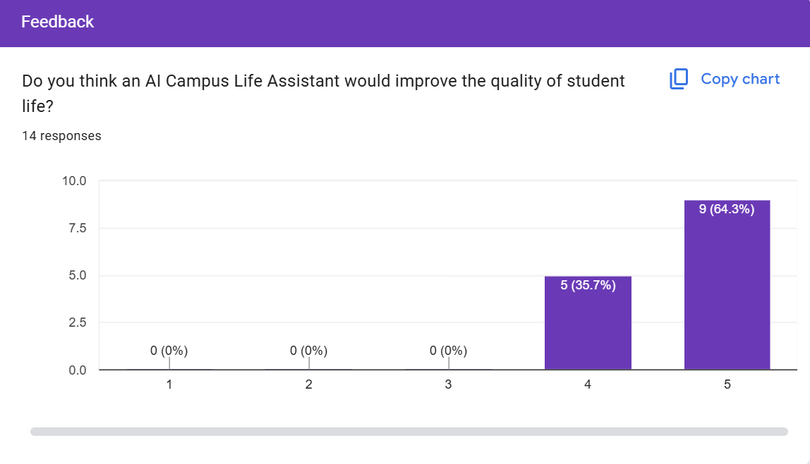
Figure 5.1

Reflection
Undertaking this design thinking project has been a profoundly educational journey that extended far beyond the technical development of a digital solution. It served as a practical immersion into human-centered design, challenging our team to move from abstract theory to empathetic practice. This process fundamentally reshaped our understanding of problem-solving within complex systems like a university campus.

The initial Empathy Phase was our most crucial lesson in humility. Designing a survey forced us to confront our own biases as students. We realized that our assumptions about common frustrations were incomplete. Reading through the survey responses, seeing people express uncertainty about where to find reliable information or detail the stress of multi-bus commutes, transformed anonymous "users" into individuals with tangible daily challenges. This phase taught us that genuine empathy requires active listening and the suspension of one’s own perspective to truly hear another's experience.

Transitioning to the Define Phase, we learned the critical discipline of synthesis. The difficulty lay not in collecting complaints, but in discerning the underlying patterns. Group discussions often involved debating which frustrations were symptoms and which were root causes. Converging on core issues like information fragmentation and a lack of integrated guidance was an exercise in analytical clarity. It underscored that a well-framed problem is the foundation of an effective solution; without this rigor, our efforts would have been scattered and superficial.

The Ideate and Prototyping Phases presented the challenge of balancing creativity with feasibility. Brainstorming sessions were energizing but could become unmoored. We learned to use our problem statement as a creative constraint, a tool that paradoxically fueled more innovative ideas by asking, "Does this directly address our core problem?" Witnessing our abstract concept of an "AI assistant" evolve into a clickable Figma prototype was a pivotal moment. It made the theoretical tangible and exposed gaps in our logic, teaching us that an idea remains hypothetical until it is visualized and subjected to the realities of user interaction.

Finally, the Testing Phase was a lesson in intellectual vulnerability and the value of iterative design. Sharing our prototype was an act of exposing our work to critique. Observing a tester struggle with a menu or request simpler language was more valuable than any internal praise. It reinforced the core tenet of design thinking: the designer is not the user. This feedback was not a critique of failure but a gift of guidance, essential for transforming our prototype from a team's deliverable into a potentially useful tool.

On a personal and collaborative level, this project highlighted the synergy of diverse strengths. Effective teamwork was a dynamic, mutual education where every insight refined our collective work. The challenges we faced, for example, scheduling conflicts, converging different viewpoints, and managing project scope, were as instrumental to our learning as the academic content itself. They taught us negotiation, compromise, and the importance of a shared vision.

In conclusion, this project has equipped us with more than a prototype; it has instilled a mindset. We leave with a deepened respect for the complexity of human needs, a structured methodology for tackling ill-defined problems, and the conviction that the most impactful technology is that which emerges from a deep, empathetic understanding of the people it aims to serve.

Task Assignment
The successful execution of this project was fundamentally based on a deliberate and synergistic distribution of responsibilities, aligning individual strengths with the core requirements of each project component. This strategic allocation fostered both depth of focus and coherence across the final report. The contributions were organized as follows:

- Wong Jian Fu assumed primary responsibility for establishing the project's foundational context. He authored the Introduction, articulating the broader relevance and necessity of the project within the contemporary digital campus landscape. Furthermore, he developed the comprehensive Project Description, which served to contextualize the problem space and clearly define the user scenario. His work ensured the report was anchored in a clear, persuasive rationale from its outset.

- Raestra Palevie Hamid focused on translating our identified problems into a tangible vision. She meticulously detailed the Problem Solution, providing a coherent and feature-specific explanation of how the proposed UTM AI Campus Life Assistant would functionally address user needs. Additionally, she authored the Team Working section, offering a reflective analysis of our collaborative methodology, group dynamics, and the processes that enabled effective cooperation throughout the design thinking cycle.

- Ariff Naim bin Zamzan was tasked with documenting the methodological backbone of the project. He systematically chronicled the Design Thinking Process, providing a structured narrative of our progression through each phase. His work on compiling the Design Thinking Evidence involved curating and presenting the key artefacts—from initial survey data to prototype iterations—that evidenced our user-centered approach and validated our iterative development.

- Rhiddhi Subha Siddique, my contributions were centered on evaluative and reflective synthesis. I developed the Assessment Points, formulating the criteria and reflective questions we used to evaluate our progress and outcomes at each stage of the process. I also composed the Reflection, a critical examination of our team's learning journey, challenges encountered, and the personal and collective insights gained. Finally, I authored this Task Assignment section to formally document and acknowledge the collaborative framework that guided our work.

This division of tasks was not merely administrative, but also reflected our team’s consultative approach. Regular meetings and online interaction ensured seamless transitions between sections, with each member providing constructive feedback on the others' work. This collaborative practice ensured that individual contributions turned into a unified, coherent, and academically robust final report.

